the cure - assembly instructions
Rev: A
Date drafted:2024-04-20
Drafted by: Kelvin Chow

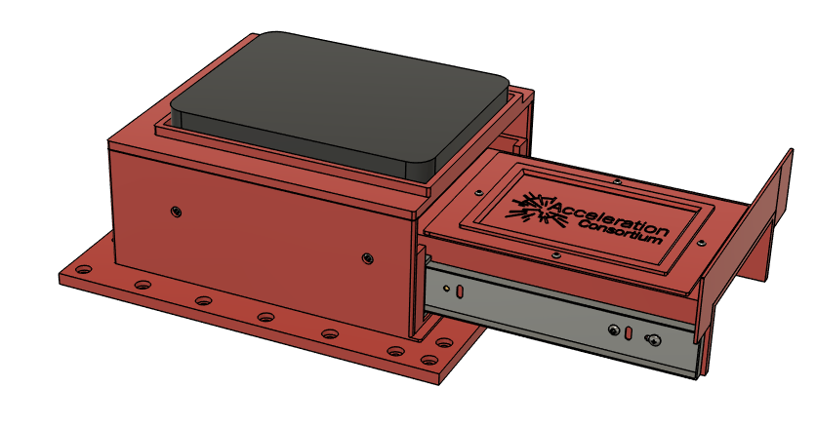

Section 1: Print Parts and Install Heat-Set Inserts
- 3D print all 9 parts (1X C1-C9,). STL files are located [here]( https://github.com/kelvinchow23/the-cure/tree/main/mechanical/3D%20prints%20and%20CAD%20files/stl)
- Install heat set inserts for the following:
  - Tray [C1]
    - m3 inserts on the top [4X B22]
    - m4 inserts on the sides [4X B23]
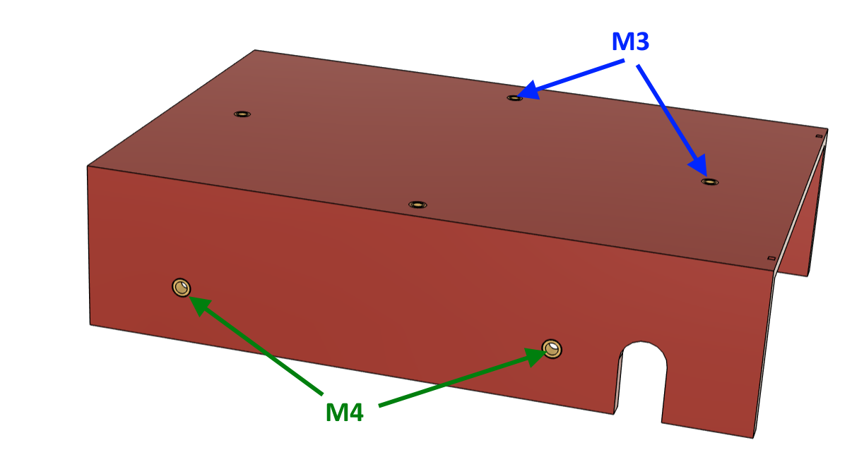
  - actuator bracket [C2]
    - m4 inserts as shown below [5X B23].
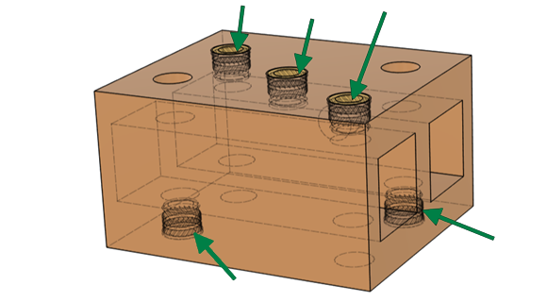
  - electronics mounting plate [C4]
    - m3 inserts [6X B22].
  - UV inner base [C6]
    - m3 inserts on the bottom and back [8X B23]
    - m4 inserts on the sides [12X B23]. Note: these need to be installed from the outside and pushed all the way flush to the inner surface
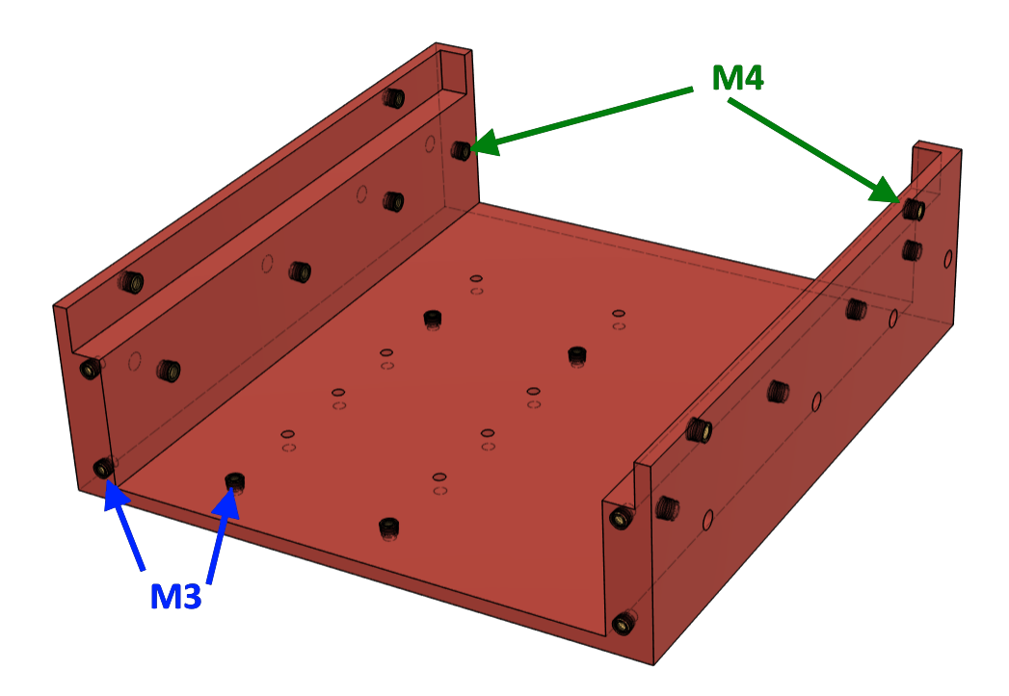
  - back connector panel [C9]
    - m3 inserts [2X B22]
    - m4 insert [1X B23].
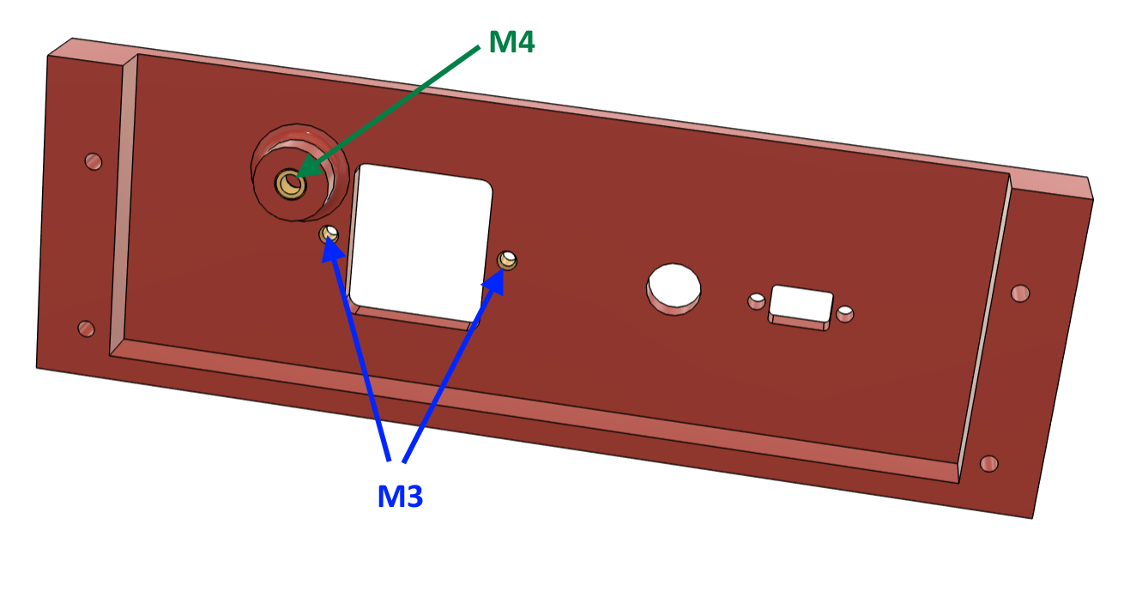

Section 2: Build Custom Cables
There are 5 custom cables to build.
Cable # | From | To | Description
E1 | WAGO + DC power (AC L + GND) | UV lamp | AC receptacle for UV lamp
E2 | Power entry module | Power supply (AC) | Feeds 120VAC to the DC power supply
E3 | Power supply (DC terminals) | Electronics board | Delivers 5V/12V to custom electronics
E4 | WAGO | AC relay | Neutral wire to relay
E5 | Power supply (AC neutral) | WAGO | Neutral line to WAGO connector

- Build cable E1: UV lamp receptacle
  - Take the power cord [B29] and measure 50cm from the connector and cut it. (Do not throw away the cable ends as they will be used for cable E2)
  - On the cut end, remove about 6cm off the black jacket and trim each of the 3 wires about 1cm.
  - Crimp on spade connectors [2X B31] to the green and white wires.
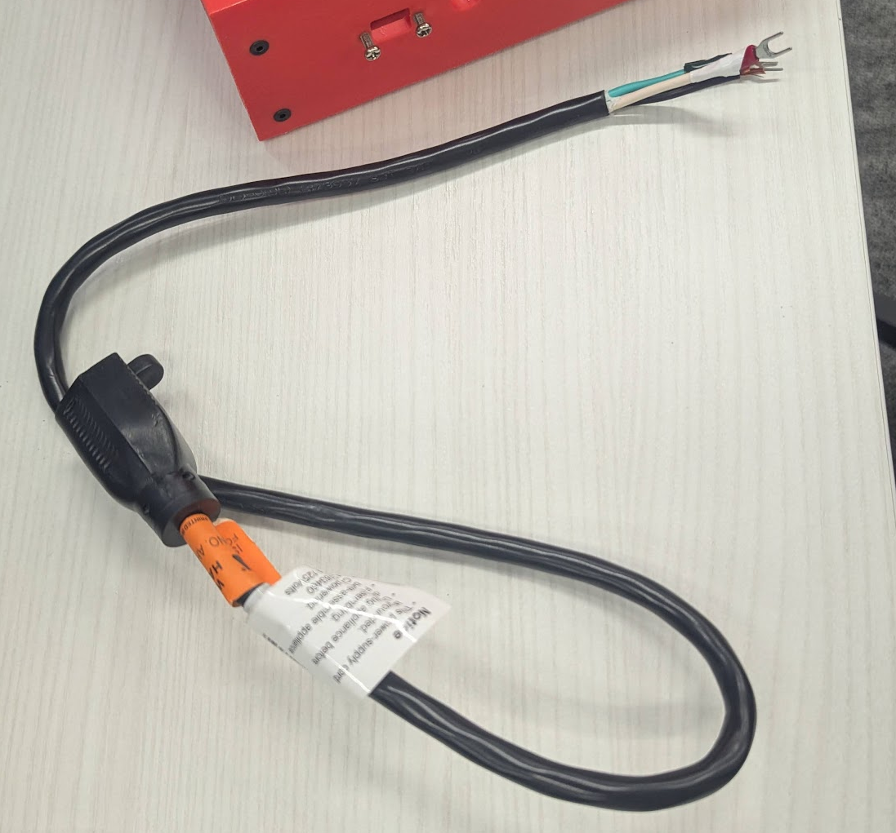
- Build cable E2: Power entry to power supply
  - With the excess cable from the previous step, cut a length of 15cm.
  - Strip off the entire black jacket to get 3 wires
  - For all cables on both ends (6 total), strip about 1cm
  - For all cables, crimp a Faston connector [3X B32 on one end and crimp a spade connector [3X B31] on the other end.
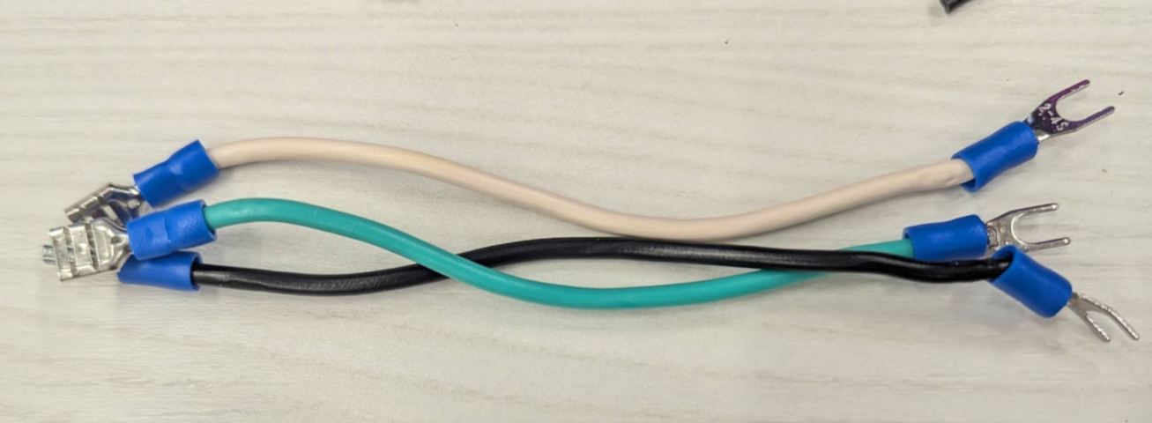
  - Connect the quick disconnect end of these wires to the back of the power entry connector [1X B20] as shown below. Connectors should snap in. The connector should be labelled N and ground. Black goes to top connection, white goes to N, and green goes to ground.
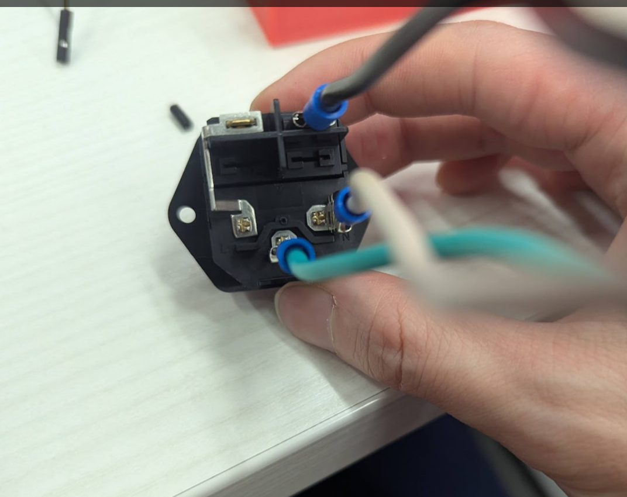
- Build cable E3: power supply to electronics
(Note: the image shows a different spade connector; use yellow instead.)
  - Take female jumper wires [3X B28]. These 3 wires will be for 5V, 12V and V-, so ideally you have a colours like black, red, and white.
  - For each wire, measure 20cm from one end of the female header and cut off the end.
  - For each wire, strip the bare end about 1cm.
  - For each wire, crimp on a spade connector [3X B30]. Note that if the crimp is not secure, solder this connection (or find a spade connector that accepts 28 AWG).
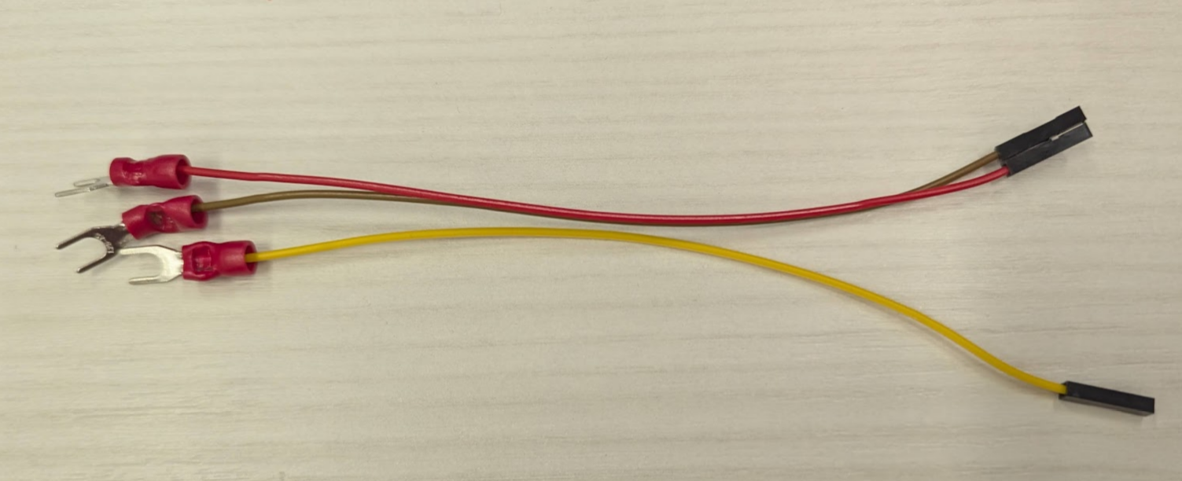
- Build cable E4 and E5: relay neutral cables
  - Take a spool of black 22 AWG stranded wire [B33]. Cut 2 wires, both 25cm in length.
  - For both wires, strip both ends about 1cm. (One of these cables [E5] is complete at this stage)
  - For only one of the wires, crimp a spade connector [1X B31] on one end. This cable is complete [E4].
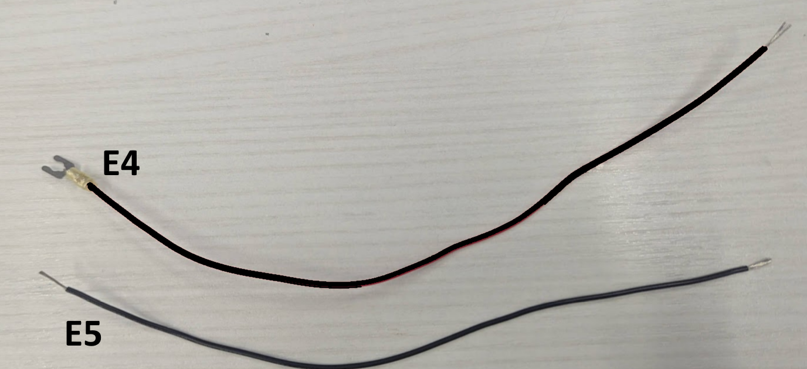

Section 3: Assemble the inner base
- Instal the pair of drawer slides [1X B17] to the inner base [1X C8] with M4x6mm button screws [12X B3]. These rails need to be extended fully to install the screws from the inner face. Note the orientation from the image below. The slides extend away from the heat set inserts on the back panel.
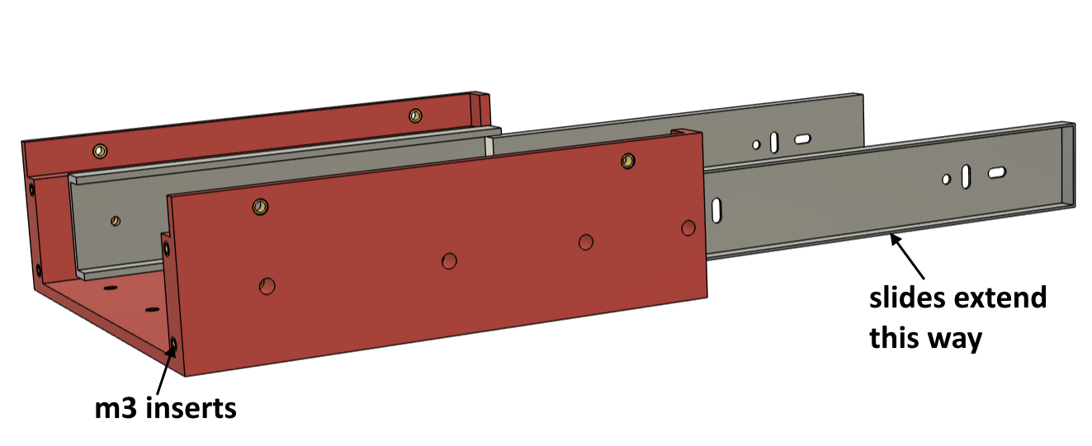
- Install the power supply [1X B18] to the electronics mounting plate [1XC4] with M3X10mm flat head screws [2X B4]
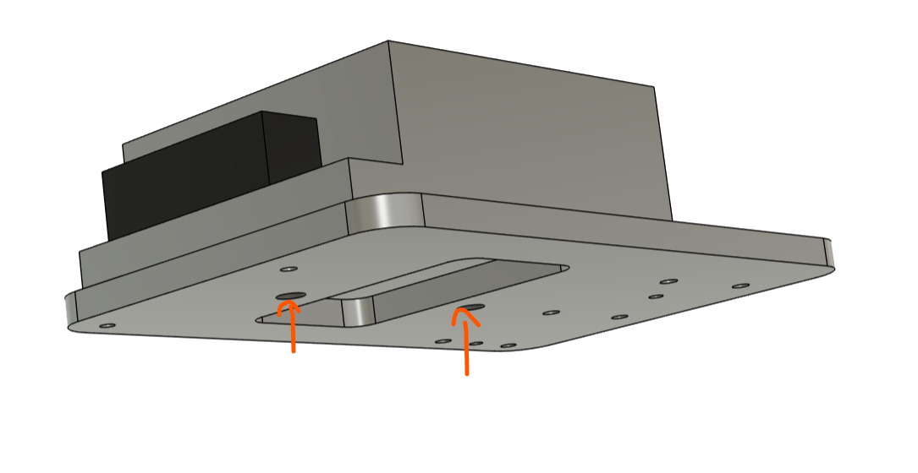
- Install the power supply and plate to the inner base using M3x10mm flat head screws [4XB4]. Note the power supplies terminal are facing at the back. They really should be installed with 4 screws, but 2 screws are blocked by the power supply. This design should have been temporary anyways.
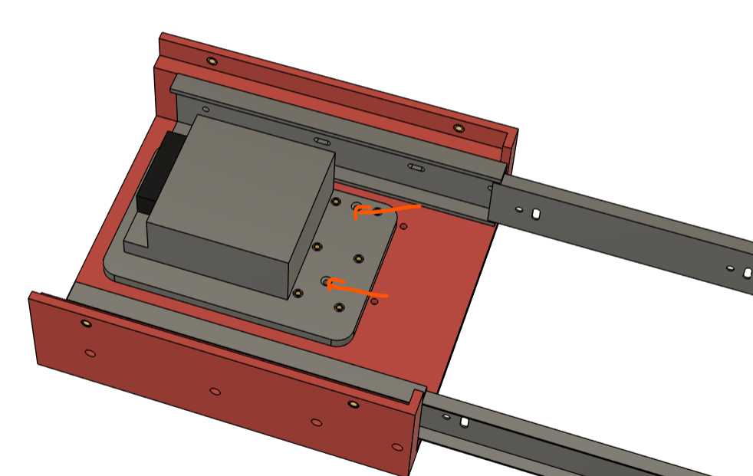
- Install nylon standoffs [4X B5] into the electronics mounting plate. Install in the inserts shown below.
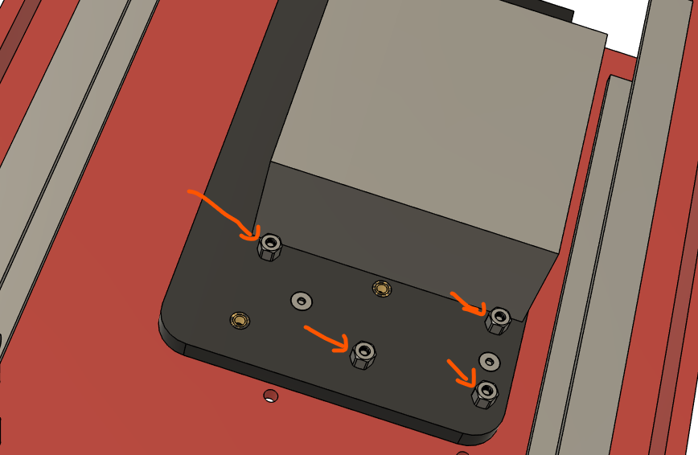
- Install the electronics control board [1X D1] onto the standoffs from the previous step. Secure with more standoffs [4X B5] (note in the image below, it is an empty protoboard, it should be populated with components).
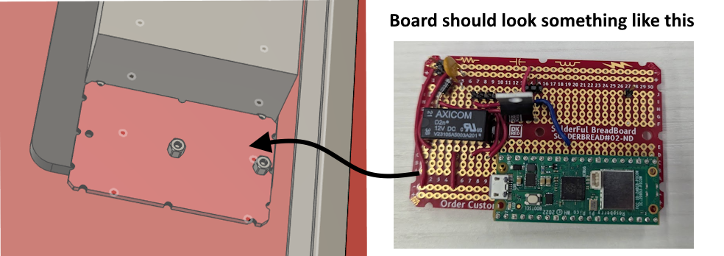

Section 4: Attach actuators to slides
- Take both actuators [2X B24] and extend them. There are a few ways to do this. The easiest way is to directly connect the actuators to a 12VDC power supply (V+ and V-). If it’s plugged in and the actuators don’t move, reverse the wires to extend.
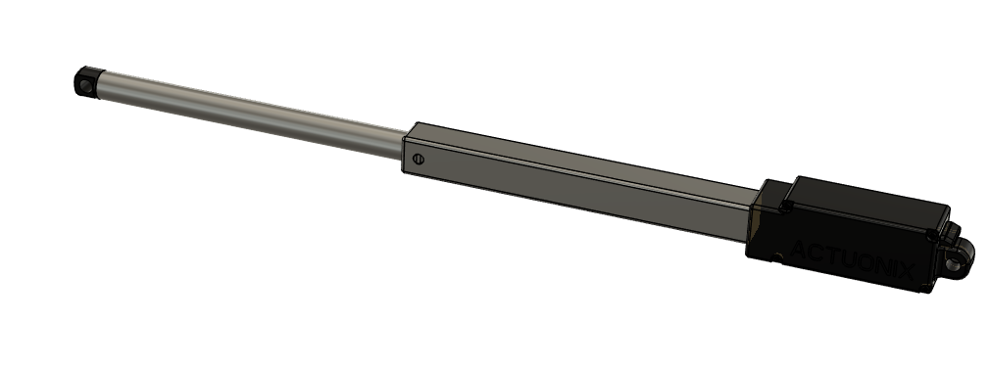
- Install the actuator mounting bracket [1X C2] to attach the 2 actuators together. The mounting bracket should slide over the shaft/housing of the actuators. Do this one at a time. Ensure that the bracket is touching the black faces of both actuators as indicated below.
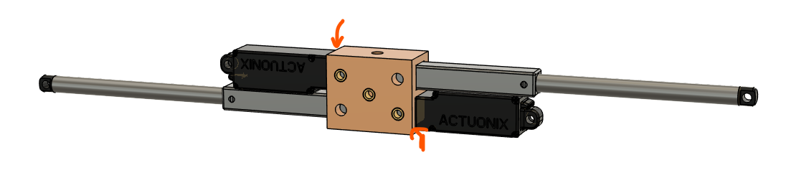
- Secure the actuators to the bracket with M4 set screws [4X B7]. Theres should be 2 set screws installed for each actuator, 1 on each side.
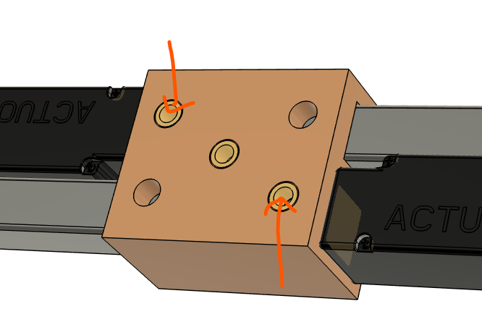

- Install a cable tie mount [1X B13] to the middle hole of the actuator mounting bracket using an M4x6mm screw [1X B3].
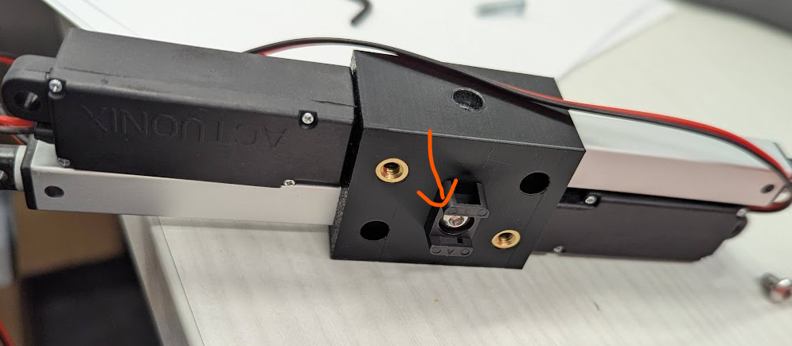
- On the right drawer slide, install the #8-32 6in screw [1X B1] and secure with an 8-32 locknut. The Actuonix actuators come with mounting hardware, which includes #8-32 locknuts. Use a different locknut (such as one with a lock washer) for easier assembly. This screw is installed into a slotted hole in the drawer slide, and positioning will need to be adjusted in a later step.
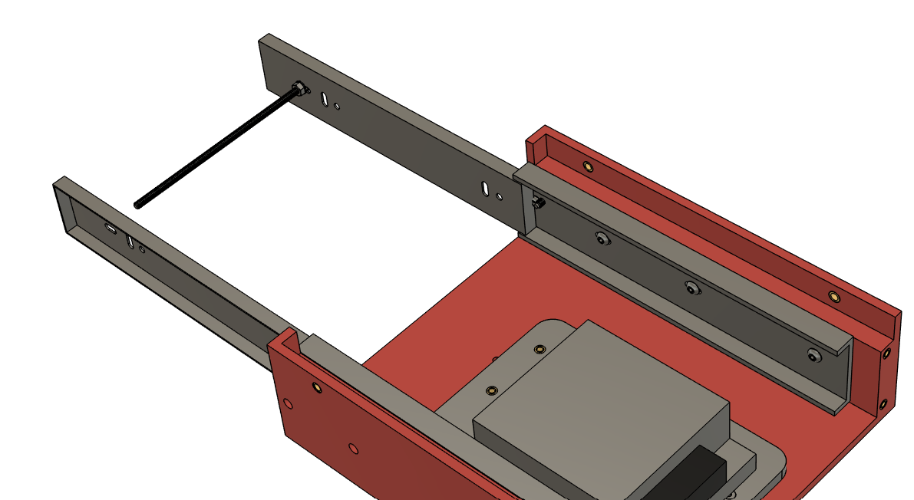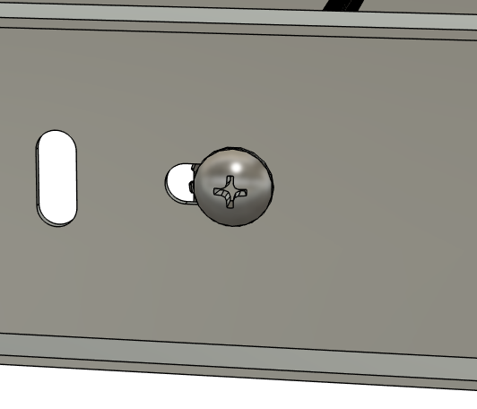
- Slide the actuator assembly over the long screw. Note the orientation of the assembly from the image below.
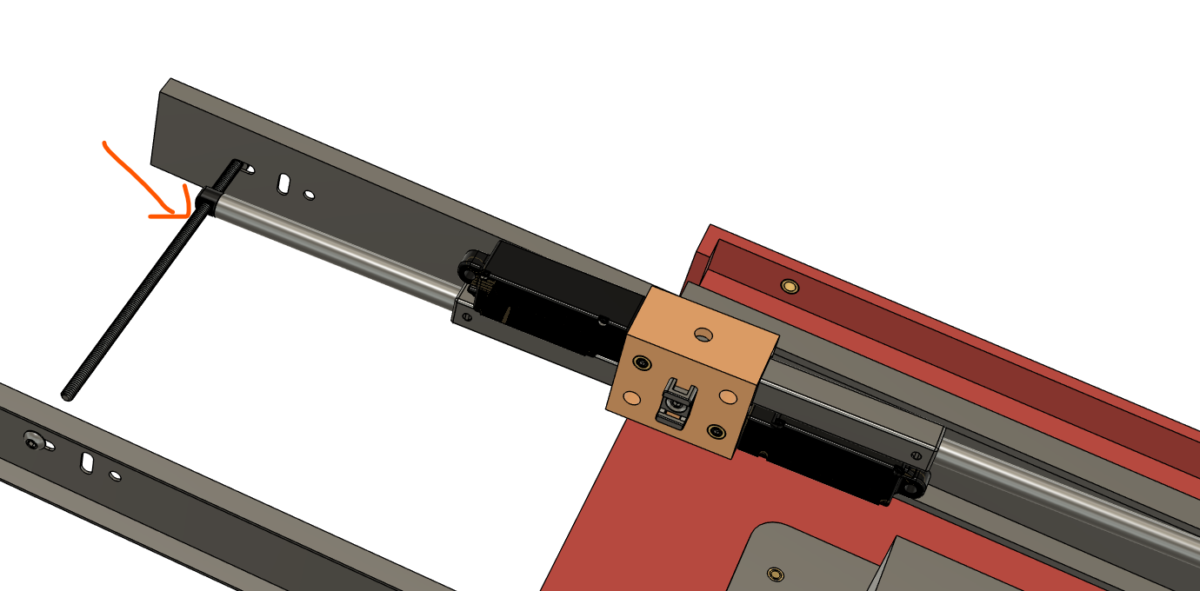

- Retract the drawer slides to a position as shown below.
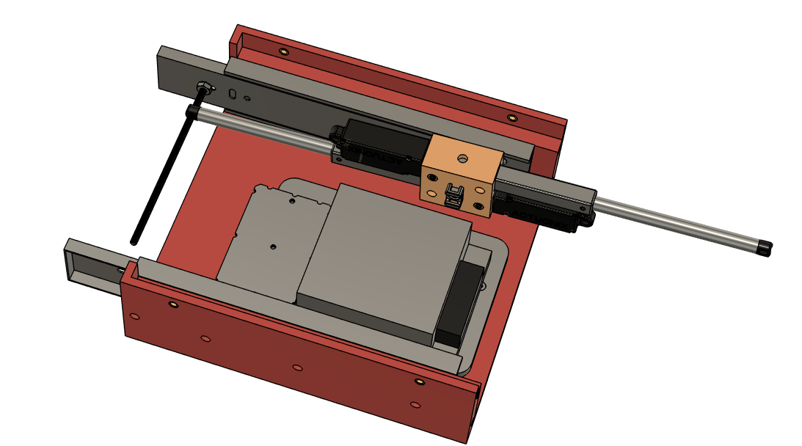
- Install the thread adapter [1X B12] on the left side with threadlocker [B15]. Note that the nut on the right side to secure the screw will probably need to be loosened to allow for the thread adapter to be installed. Install the thread adapter so it is touching the left drawer slide’s inner face. Re-tighten the right nut if necessary.
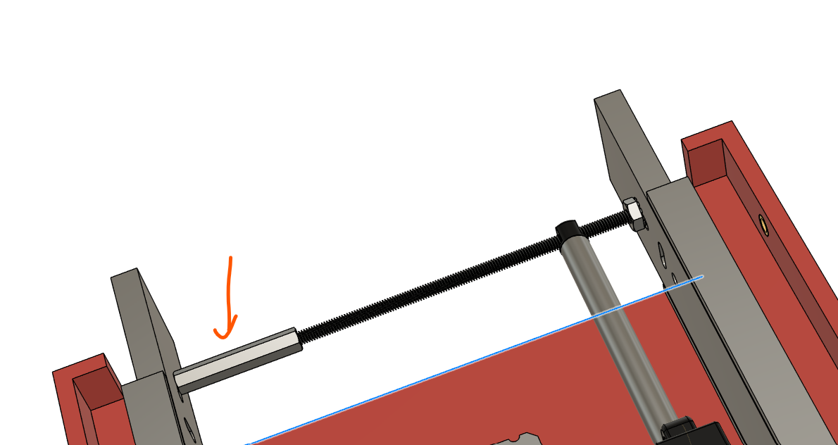
- Install an M4 x 6mm long screw [1X B3] on the right drawer slide to secure the thread adapter/long screw. Use threadlocker [B15]. After this is installed, ensure that the drawer slide can freely slide in and out. If not, readjust the positioning of the thread adapter.
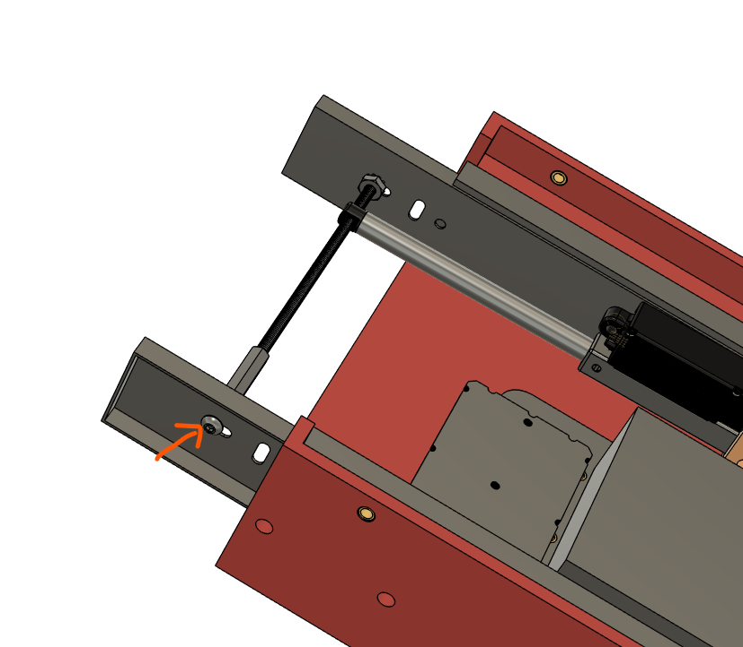

Section 5: Install back panel and begin cable wiring
- Take the back connector panel [1X C9] and install the following components.
  - USB cable [1X B19] on the left side. Secure this with M3x10mm screws [2X B6].
  - Power entry connector [1X B20]. In Section 2, this connector was pre-assembled with 3 cables, cable E2. Feed these cables through the right rectangular cutout and secure with M3 flat head screws [2X B8].
  - The smaller circular cutout in the middle is for the E1 cable that was assembled in section 2. Feed this cable through the hole (missing in the image below).
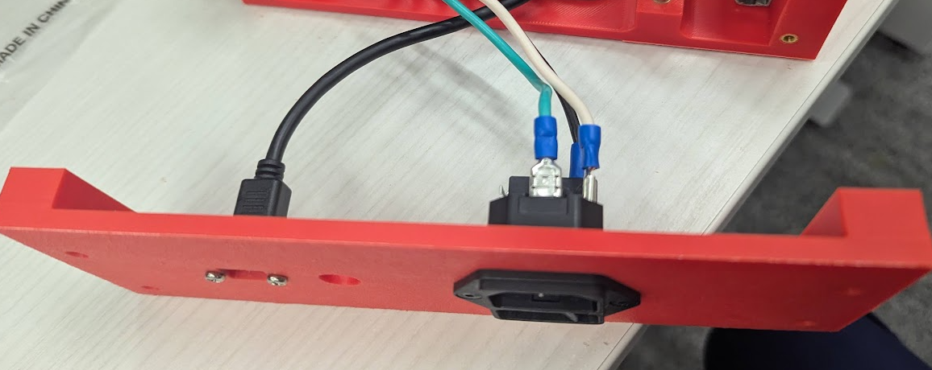
- Install the Actuonix mounting bracket [1X B25] using threadlocker and an M4x6mm screw to the back connector panel.
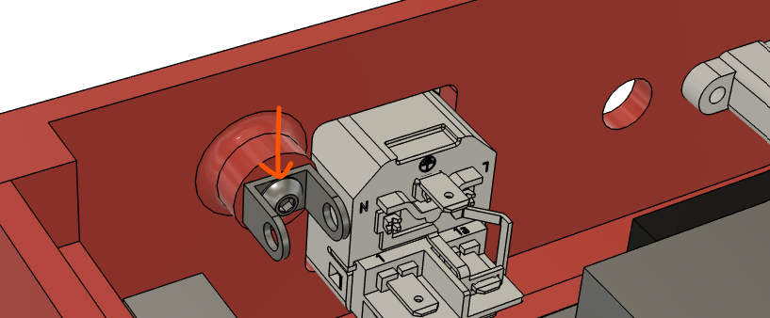
- Install the rod end of the actuator to this bracket. Use an M4x15mm screw [1XB11] and a M4 nylon-insert locknut [1X B14].
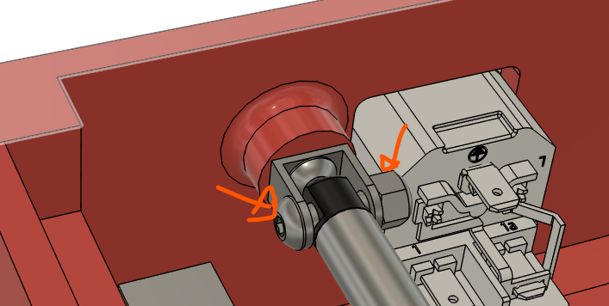
- Connect the wires from the 2 actuators to the electronics control board (relay pins). During testing, the polarity of the wires should have been figured out which way to connect them.
- Route the wires through a cable tie at the centre of the actuator mounting bracket.
- This step is optional and not shown in the picture below, but it is a very good idea to provide an external way of supply 12VDC to these actuators in case there is a situation where this module or its electronics are damaged/disconnected. What was done after was a 2 pin jumper wire was soldered in parallel to the actuator wires. The other end of the jumper wires were taped down to the 3d printed housing in a location that was accessible for a user after the module was fully built.
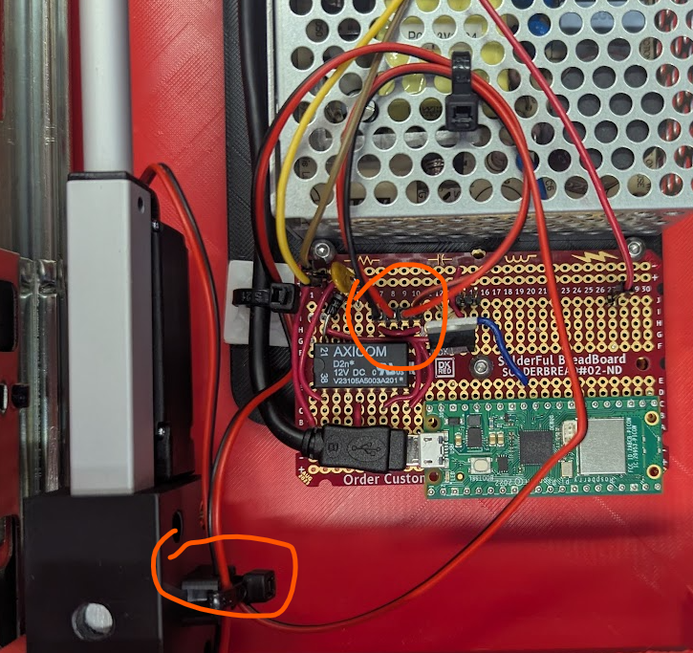
- Wire cable E2 from the power entry module to the power supply’s AC terminals. The AC terminals should be on the right side. They should be wired accordingly
- Black to L (Live)
- White to N (Neutral)
- Green to ground symbol
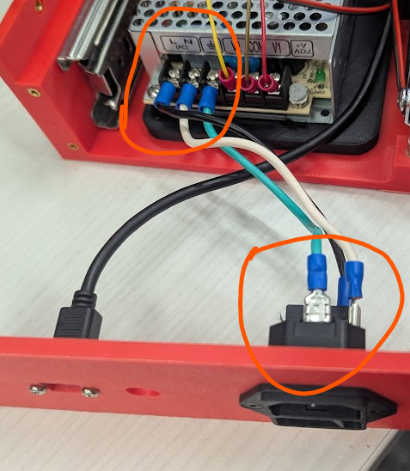
- Plug in a power cable [1X B26] to the power connector module and turn it on to test the power supply. A green LED should turn on. If probing the DC terminals with a multimeter, V1/COM should be 5V and V2/COM should be 12V. There is a screw on the right to adjust voltage if necessary.
- Wire all the electronics together, but this should all be done without the back connector panel installed yet. Refer to the schematic and the image below for general guidance on how to install the power connector module, power supply, electronics control board, and relay. The notes below are probably in chronological order of how it should be wired.
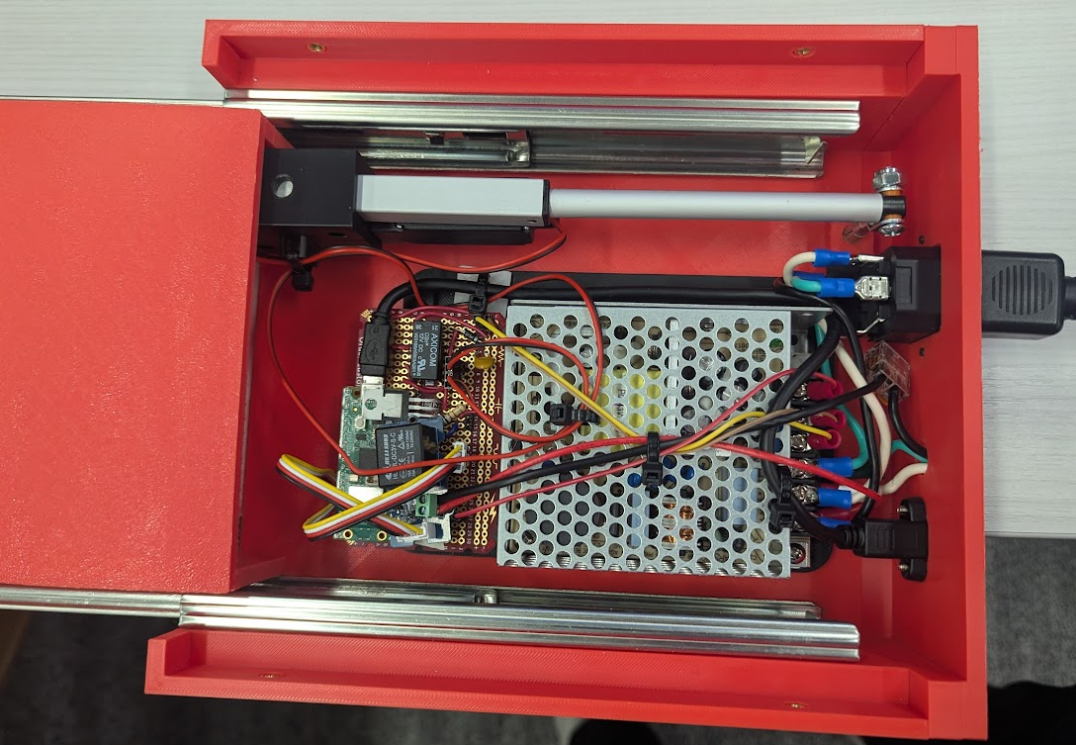
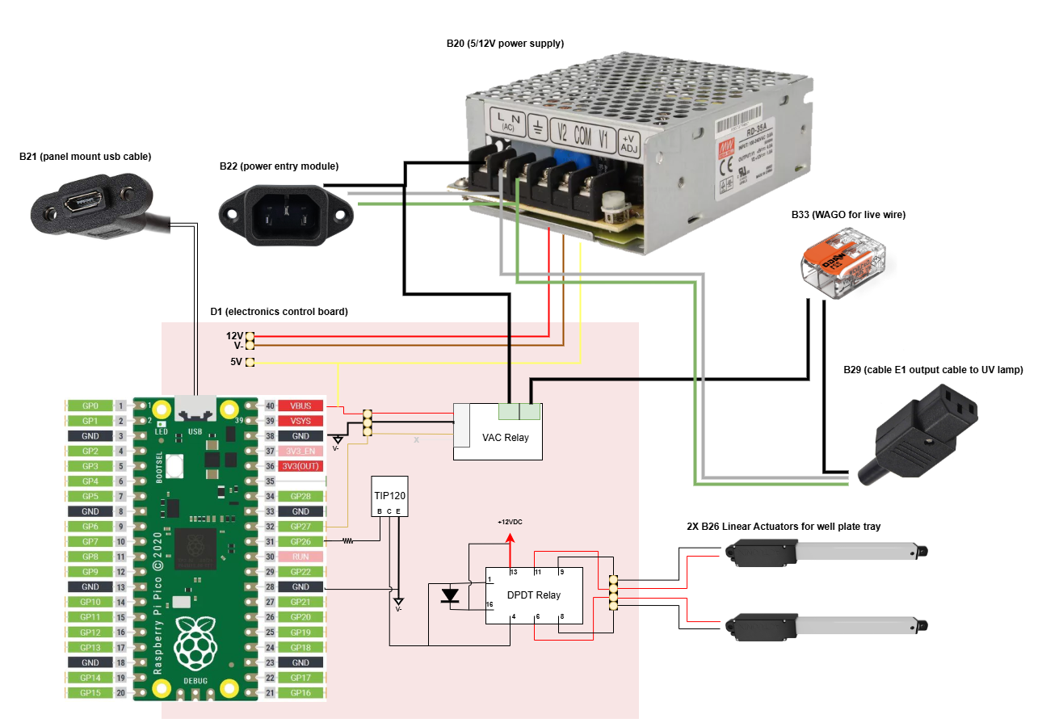

- For the AC terminals on the power supply, there should be 2 connections on each of the 3 terminals.
  - Live: Black wire from the power connector (cable E2) and cable E4 to the relay. Note that it is red in this picture and in Section 2 (and in the wiring diagram), this wire is black.
  - Neutral: White wire from cable E2 and cable E1.
  - Ground: green wires from cable E2 and cable E1.
- The DC terminals on the power supply connect to the electronics control board to provide power. In he image above,
  - Yellow provides 12V (V2 on the power supply)
  - Brown is the V- rail (COM on the power supply)
  - Red provides 5V to power the pico (V1 on the power supply).
- Connect the micro-USB to the raspberry Pico.
- Wire the relay.
  - The grove wire should connect between the relay to electronics control board.
    - Black connects to ground
    - Red connects to 5V
    - White is not connected
    - Yellow connects to a GPIO pin on the raspberry Pico
  - The AC screw terminals on the relay are interchangeable and connect to:
    - The other end of cable E5.
    - Cable E4.
- On the other end of cable E4 (black wire bare on both ends), connect it to the WAGO connector. The other end should connect to the black wire of cable E1.
- Once all wiring is complete, secure the relay in the location below. On the backside of that relay, there is double sided tape [B27] that both insulates and secures it to the standoffs/electronics control board.
- Install the back connector panel with M3x20mm long screw [4X B9].
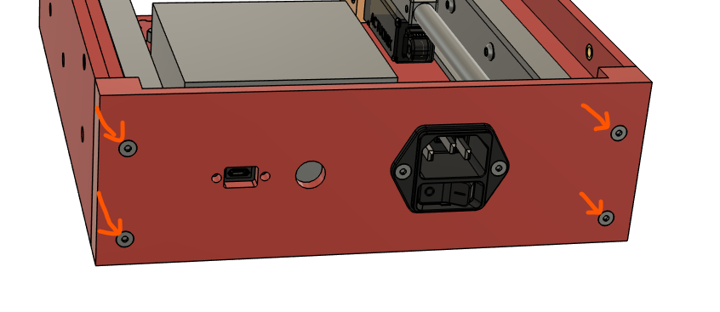
- Test that the electronics function as expected.
  - Connect a power cable to the power entry cable. Flip the switch to the ON position.
  - Connect a micro usb-B cable to the back panel connector to a computer
  - Upload the script, UV_module.py to the pico, which can be found [here](https://github.com/kelvinchow23/the-cure/tree/main/scripts). The pico should be running micropython.
  - Note the COM port of the pico.
  - Run the script, UV_module_controller.py. This should loop through the workflow. Check for the following:
    - When the actuator is fully retracted, the drawer slides should also be fully retracted. If not, adjust the position of the screws securing the actuator to the drawer slide.
    - When the relay is switched on or off, an audible click is heard.
- While testing the actuators, look at the wires when the actuators move. Avoid loose wires dangling and secure them down with cable ties [B21]. Note in the image below the cable ties used to secure the wires. The lone exception is the wires for the actuator, which needs to move. Allow for some slack there, but those wires shouldn’t be taking up vertical space either.
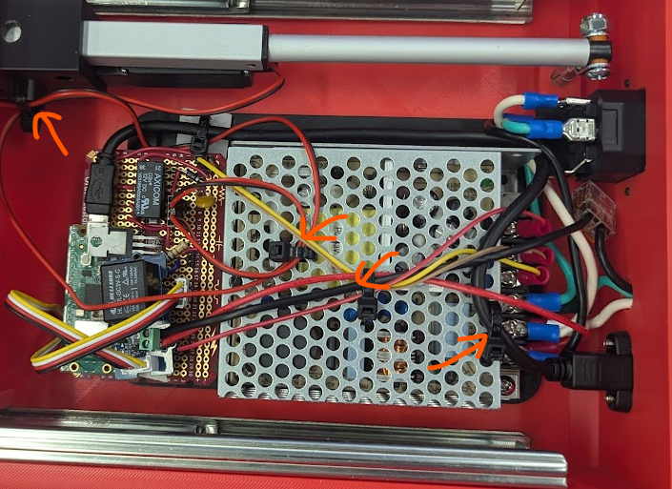

Section 6: Install remaining 3D printed parts
- Extend the actuators fully (either modify the script or run the existing script and shut off the power when the actuator is fully extended).
- Secure the well plate tray [1X C1] to the drawer slides with M4x6mm screw [4X B3]. Note that there is an issue where the front 2 screws can be installed, but the back 2 screws cannot be. The location circled in blue could be installed from the inside, but the location circled in green could not (blocked by the actuators).
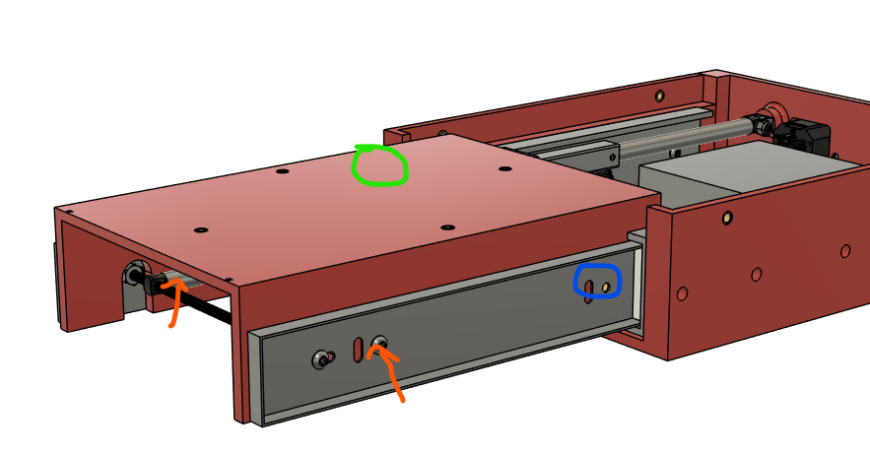
- Re-run the script to test the movement doesn’t interfere with the wires. If they do, re-secure the wires.
- Install the tray insert [1X C3] to the well plate tray using M3x6mm screw [4X B2].
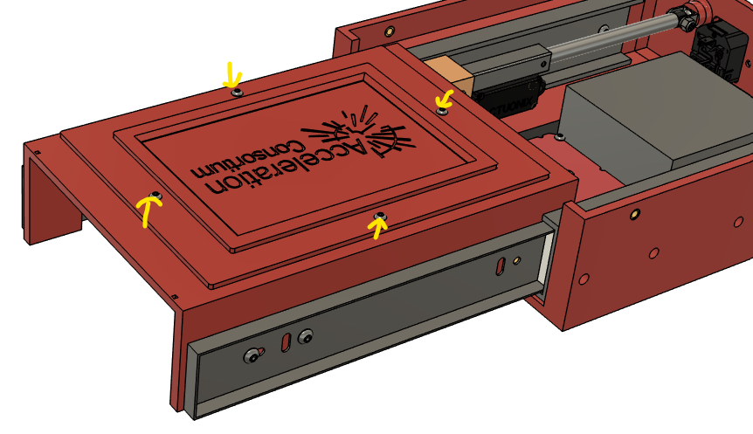

- Install this current assembly into the outer base [1X C5]. Secure with M4x10mm screws [4X B10].
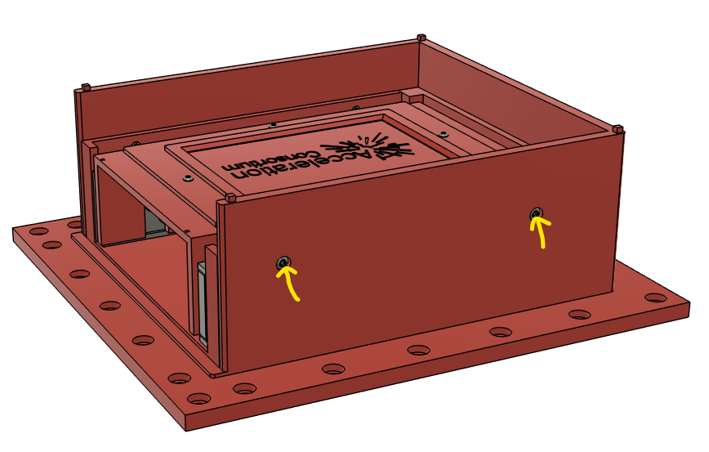
- Glue the shield [1X C6] to the well plate tray as shown below.
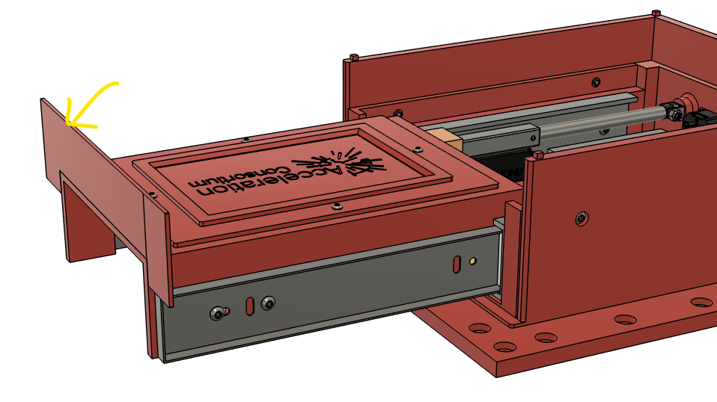
- Snap the base lid [1X C7] to the top of the outer base.
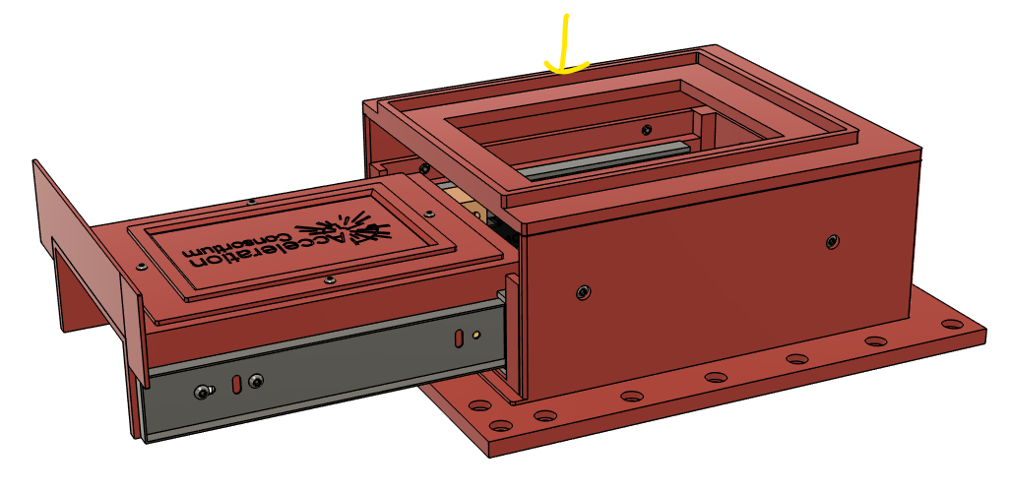
- Place the UV lamp [1X B16] onto the lid. Connect the lamp’s power cord to the receptacle dangling from the back connector panel [cable E1].
